Pizza sales report

Tool-sql

1.Total revenue of pizza sale

select cast( sum(total_price) as decimal(10,2)) as Total_Revenue from pizza_sales

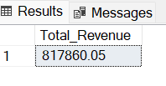

2. average order value

select cast(sum(total_price)/count (distinct order_id)as decimal(10,2)) as Avg_order_value from pizza_sales

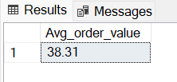

3. total Pizza sold

select sum(quantity) as Total_pizza_sold from pizza_sales

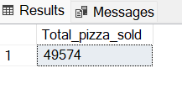

4. Total Orders

select count (distinct order_id) from pizza_sales

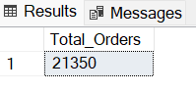

1. Average pizza per order

select cast( cast(sum(quantity) as decimal(10,2)) /

cast(count(distinct order_id)as decimal(10,2)) as decimal(10,2)) as Average_pizza_per_order from pizza_sales

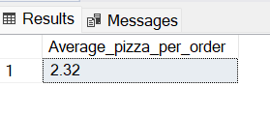

1. Hourly trend for pizza sold

select DATEPART(HOUR,order_time) as order_hour,sum(quantity) as pizza_sales

from pizza_sales

group by DATEPART(HOUR,order_time)

order by DATEPART(HOUR,order_time)

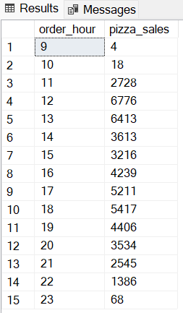

1. Weekly trend for total orders

select DATEPART(iso_week,order_date) as No_of_weeks, year(order_date) as Order_year,count(distinct order_id)as Total_order

from pizza_sales

group by DATEPART(iso_week,order_date), year(order_date)

order by DATEPART(iso_week,order_date), year(order_date)

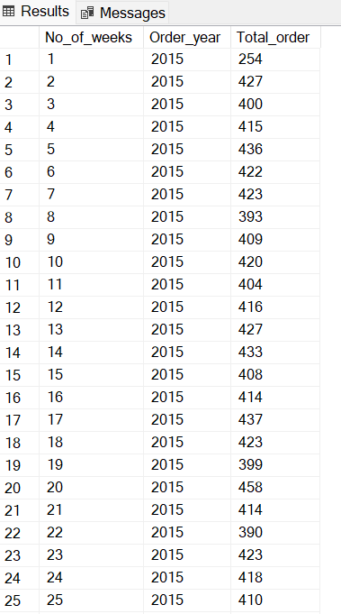 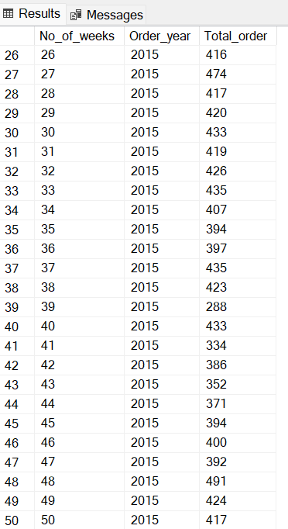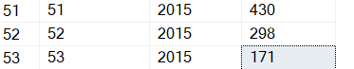

1. Daily trend for total orders

select DATENAME(DW,order_date) as order_day, count(distinct order_id) as total_orders from pizza_sales

group by DATENAME(DW,order_date)

order by order_day order by total_orders

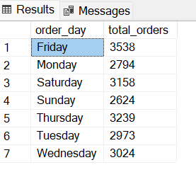

1. Monthly trend for total order

select DATENAME(MONTH,order_date) as order_month, count(distinct order_id) as total_orders from pizza_sales

group by DATENAME(MONTH,order_date)

order by DATENAME(MONTH,order_date)

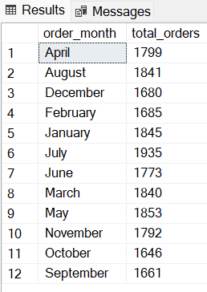

1. Quaterly trend for total order

select DATENAME(DW,order_date) as order_day, count(distinct order_id) as total_orders from pizza_sales

where DATEPART(QUARTER, order_date)=1

group by DATENAME(DW,order_date)

order by DATENAME(DW,order_date)

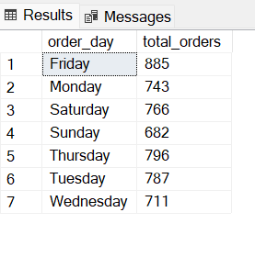

11. Percentage of sales by pizza category

select pizza_category,cast(sum(total_price)as decimal(10,2)) as total_revenue,

cast( sum(total_price)*100/(select sum(total_price) from pizza_sales) as decimal(10,2)) as sales_percentage

from pizza_sales

group by pizza_category

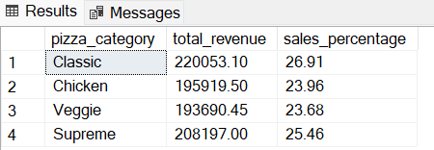

1. Percentage of sales by Pizza size

select pizza_size, cast(sum(total_price) as decimal(10,2)) as total_orders, cast(sum(total_price)*100/ (select sum(total_price) from pizza_sales )

as decimal(10,2))as pct from pizza_sales

group by pizza_size

order by pct

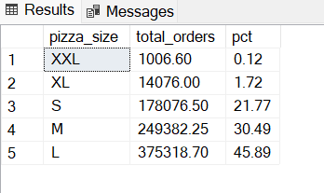

1. Top 5 pizza by Revenue

select top 5 pizza_name,sum(total_price)as Total_Revenue from pizza_sales

group by pizza_name

order by Total_Revenue desc

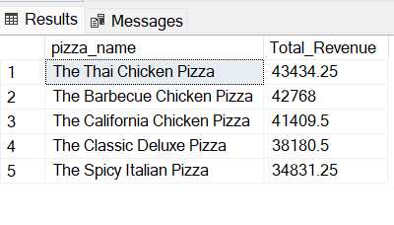

1. Bottom 5 Pizza by total revenue

select top 5 pizza_name,sum(total_price)as Total_Revenue from pizza_sales

group by pizza_name

order by Total_Revenue

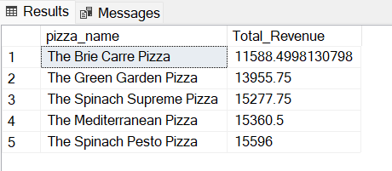

1. Top 5 pizza by total orders

select top 5 Pizza_name, count(distinct order_id) as Total_Orders from pizza_sales

group by Pizza_name

order by Total_Orders desc

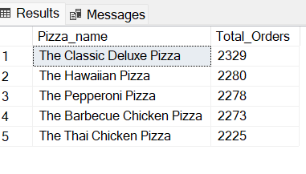

1. Bottom 5 pizza by total orders

select top 5 Pizza_name, count(distinct order_id) as Total_Orders from pizza_sales

group by Pizza_name

order by Total_Orders

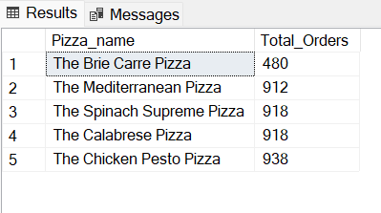

1. Top 5 pizza by Quantity

select top 5 Pizza_name, sum(quantity) as Total_pizza_sold from pizza_sales

group by Pizza_name

order by Total_pizza_sold desc

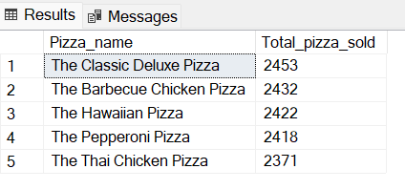

1. Bottom 5 pizza by Quantity

select top 5 Pizza_name, sum(quantity) as Total_pizza_sold from pizza_sales

group by Pizza_name

order by Total_pizza_sold

